**Stanford Library**

**STAKEHOLDERS**

|  |  |
| --- | --- |
| **ACTOR** | **What he can do on the Software Created** |
| Library Staff | Manage Books records  Update information Library Management System |
| Readers/Users | Borrow books and reading material  Re- issue  Search a Book  Pay Penalty – Fine |
| Management | Able to fetch reports |

**PROBLEM DEFINITION AND SOLUTION**

* A lot of time is wasted managing the manual library.
* The number of employees needed to manage the library is high.
* Fine calculation is a tedious and time-consuming affair.
* No reports could be generated on books issued due to the manual system.
* It is difficult to manage 4 million books present in the library.
* Students could deposit the books only in the library timings.

**Advantages of LMS**

Advantages of Library Management System:

* Reduce overheads and increase productivity of library staff
* Cost reduction
* Up-to-date records of all books, research papers, magazines, and other materials available in the library
* Improve student engagement in the library
* It will generate dynamic reports for better decision-making

**EXISTING SYSTEM**

Currently the Library operations are manual , time consuming , complex and requires lot of man power

**PROPOSED SYSTEM**

The Proposed sytem will be an automated LMS With following capabilities:

Search Facility

Report Generation

Time Saving

Access to free e-journals and e- books through the software.

**SCOPE using Use Case Diagram (UML)**

Create a use case diagram including all the actors and processes for an end to end process of the system.

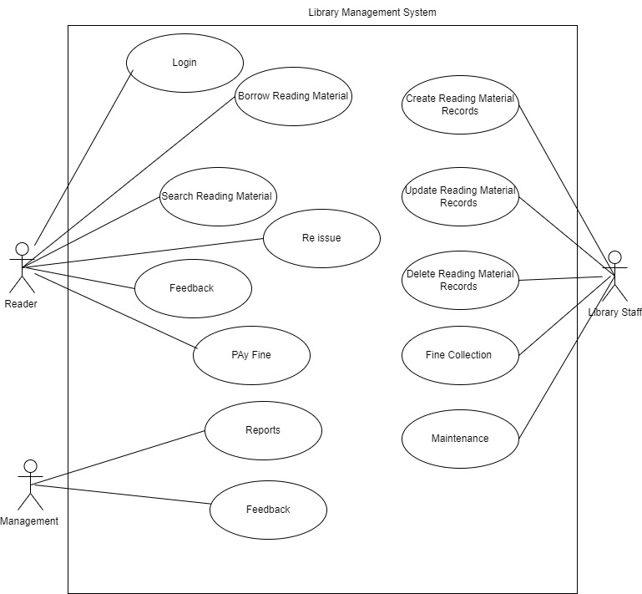

**DATA FLOW DIAGRAM**

Create a data flow diagram.

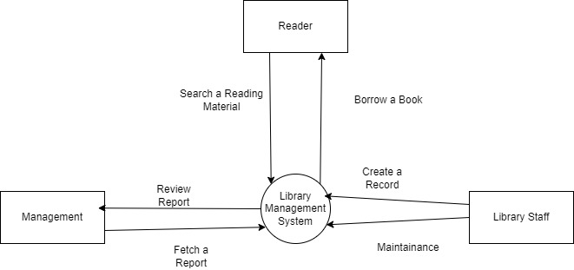

**IN SCOPE**

* Login: The user shall have Login credentials to enter into the application.
* Create Record: Library Staff will have the feature to create the Record
* Modify Record
* Delete Record
* Calculation of Fine
* Reissue Books
* Review
* Report
* Search Book
* Pick a Location to drop the borrowed material

**OUT OF SCOPE**

* The books will not be issued to other campus within Standford universities.

**Wireframes:**

Create sample wireframes for the system. Capture what screen will be show to the library employees to create records for each book and at what stage in the system.

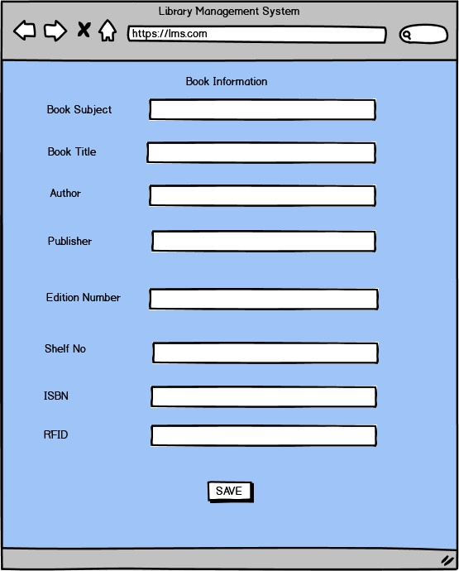

**FUNCTIONAL REQUIREMENTS**

Login: The user shall have Login credentials to enter into the application.

Create Record: Library Staff will have the feature to create the Record

Modify Record

Delete Record

Calculation of Fine

Reissue Books

Review

Report

Search Book

Pick a Location to drop the borrowed material

**NON-FUNCTIONAL REQUIREMENTS**

Write all the nonfunctional requirements for the system.

**System Requirement:**

* LMS can be used on any Windows and MacOS run computers
* Users will need an active internet connection.
* It will be RFID ready (NCIP 2.0 HTTP server available)
* Auto scheduled tasks like emails and database maintenance
* Data should be stored in cloud
* Highly secure, scalable, and reliable

**Usability:** The screens should be self-explanatory and very user friendly.

**Environments**

We are going to be creating and maintaining the program in Java. We chose Java because it will not change much over time and if we make it well, there will be very little maintenance to be done on the code.